# Use Case Document – Missing Persons Finder Application

## Use Case 1.2 – Create Missing Person Record

## Create Missing Person Record

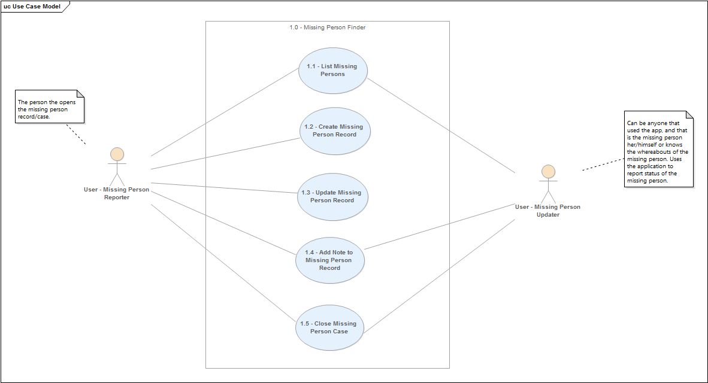

|  |  |
| --- | --- |
| Use case description detail | This is use cases cover the activity of creating a new missing person record. The actor, a user with the knowledge of a missing person, uses the system to create a new record with all known details related to the missing person, himself, and if possible, a photograph of the missing person.  The user saves the new missing person record which becomes available system-wide. |
| Related Requirements | The following requirements are fulfilled:   * The system will allow the creation of new missing person records. * A missing person record will be available system-wide so other app users can view the missing person record, and if information is available about the missing person, provide details on the whereabouts or status of the missing person. * The system will all missing persons based on a criteria set by the app user, or the location of the app user provided location services are enabled. |
| Goal In Context | This use case fulfills one of the most important goals of the system: allow app users to report known missing persons, so that the new record created can be used to locate the missing person through the network of information provided by the body of users of the Missing Persons Finder Application. |
| Preconditions | * Network connection to central database is active * The user has minimal information about an actual missing person * User searched the Missing Persons Database for the missing person, and has determined that s/he is not in the system yet. |
| Successful End Condition | A Missing Person Record has been successfully created in the application. |
| Failed End Condition | A Missing Person Record is not created in the application due to a system or connectivity error when attempting to submit the information to the backend system. |
| Primary Actors | Application User – Missing Person Reporter |
| Secondary Actors | Missing Person |
| Trigger | The event triggered by the missing person reporter, who has knowledge of a missing person and has the ability to report it through the Missing Persons application. |
| Main Flow | 1. User opens the application 2. User searches database for missing person and does not find him/her 3. User taps the “+” button in main form of the application 4. User enters all the information known about the missing person, and himself 5. User verifies all the information and presses the save button. 6. Record is successfully created in the database and user is notified through a status message on the application screen. |
| Extensions | 1. Missing person already in the database    1. User opens the application    2. User searches database for missing person and finds him/her    3. User creates a new note (Use Case 1.4) with all the information known to him about the missing person.    4. User verifies all the information entered and presses the save button    5. The note record is successfully created in the database and the user is notified through a status message on the application screen 2. The Missing Person Application is unable to establish a connection to the database    1. When the user tries to save a new missing person record or a note record, an error message is shown stating the a connection to the database is not possible and to try again later or when user is within reach of service. 3. Missing Required information    1. User attempts to save Missing Person Record or Note, without entering all required information.    2. An error message is displayed on the application screen informing the user that critical minimum information is missing and the s/he must provide that information in the highlighted fields before saving the record. |